- ACCESS CONTROL AND AUTHENTICATION ASSIGNMENT
Q1. Simple Login Form for a Mock Zomato Admin Panel
Objective: Create a basic HTML login form that checks a hardcoded username and password. 'Access Granted' is shown only when both values are correct.
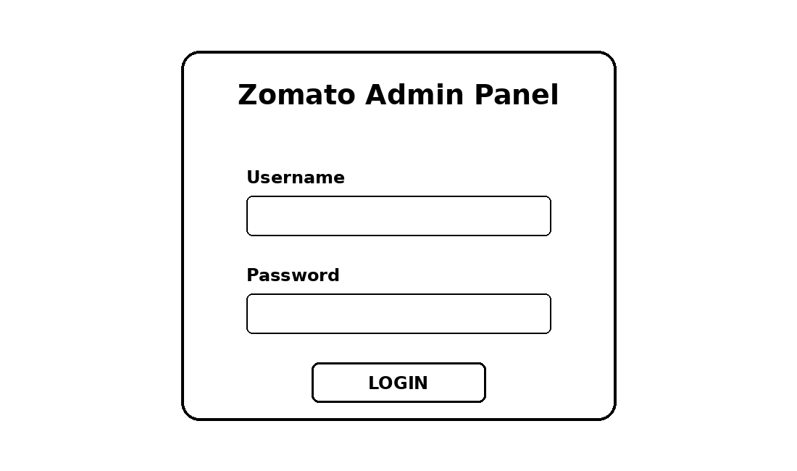
Figure: Example design for the mock admin login form.
HTML + JavaScript Code:
<!DOCTYPE html>
<html>
<head>
<title>Zomato Admin Login</title>
</head>
<body>
<h2>Zomato Admin Panel</h2>
<input type="text" id="username" placeholder="Username"><br><br>
<input type="password" id="password" placeholder="Password"><br><br>
<button onclick="login()">Login</button>
<p id="result"></p>
<script>
function login() {
let user = document.getElementById("username").value;
let pass = document.getElementById("password").value;
if (user === "admin" && pass === "admin123") {
document.getElementById("result").innerText = "Access Granted";
} else {
document.getElementById("result").innerText = "Access Denied";
}
}
</script>
</body>
</html>
Test credentials: Username = admin, Password = admin123. These are only mock credentials for the assignment.
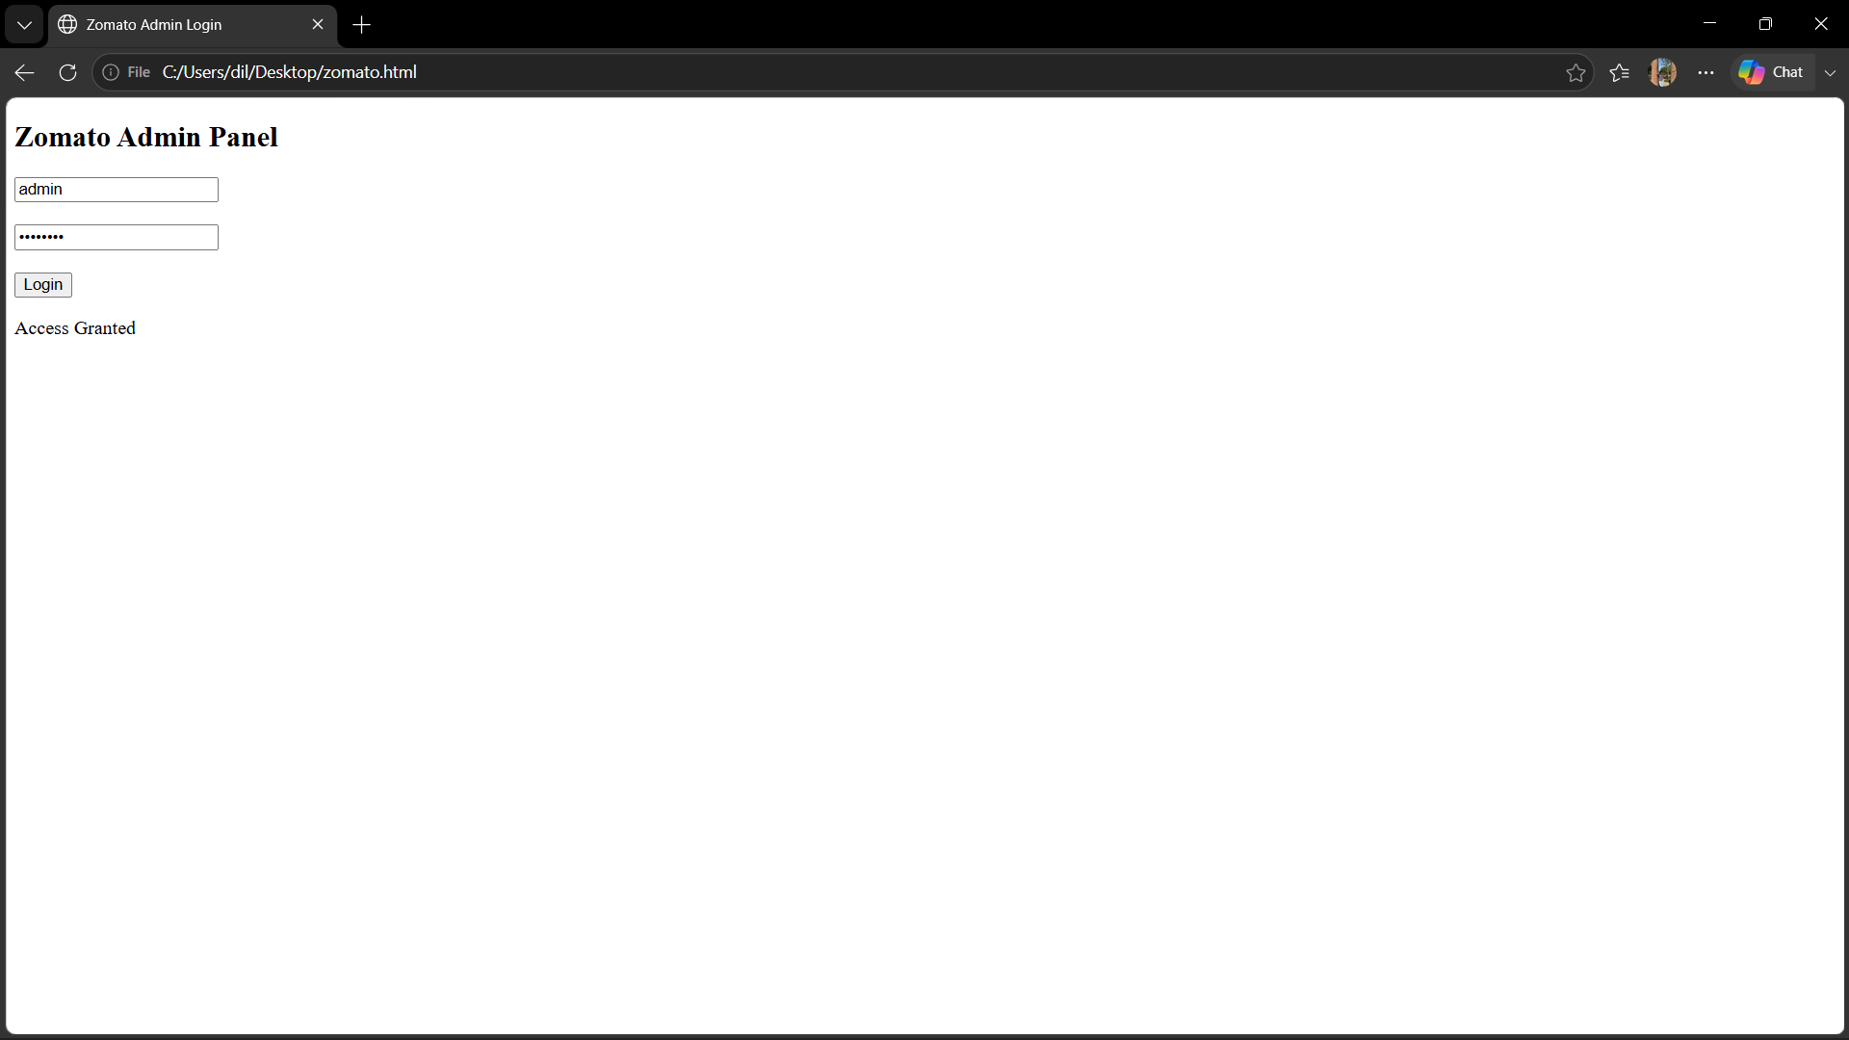
Q2. Python Function to Check Role-Based Access
This program uses a dictionary to map each user role to the resources that role is allowed to access.
def check_access(user_role, resource):
permissions = {
"customer": ["order_history"],
"restaurant_owner": ["menu_edit", "order_history"],
"admin": ["menu_edit", "order_history", "admin_dashboard"]
}
return resource in permissions.get(user_role, [])
print(check_access("customer", "order_history")) # True
print(check_access("customer", "menu_edit")) # False
print(check_access("restaurant_owner", "menu_edit")) # True
print(check_access("restaurant_owner", "admin_dashboard"))# False
print(check_access("admin", "admin_dashboard")) # True
Explanation: The function returns True when the requested resource is present in the list allowed for that role. Otherwise, it returns False.
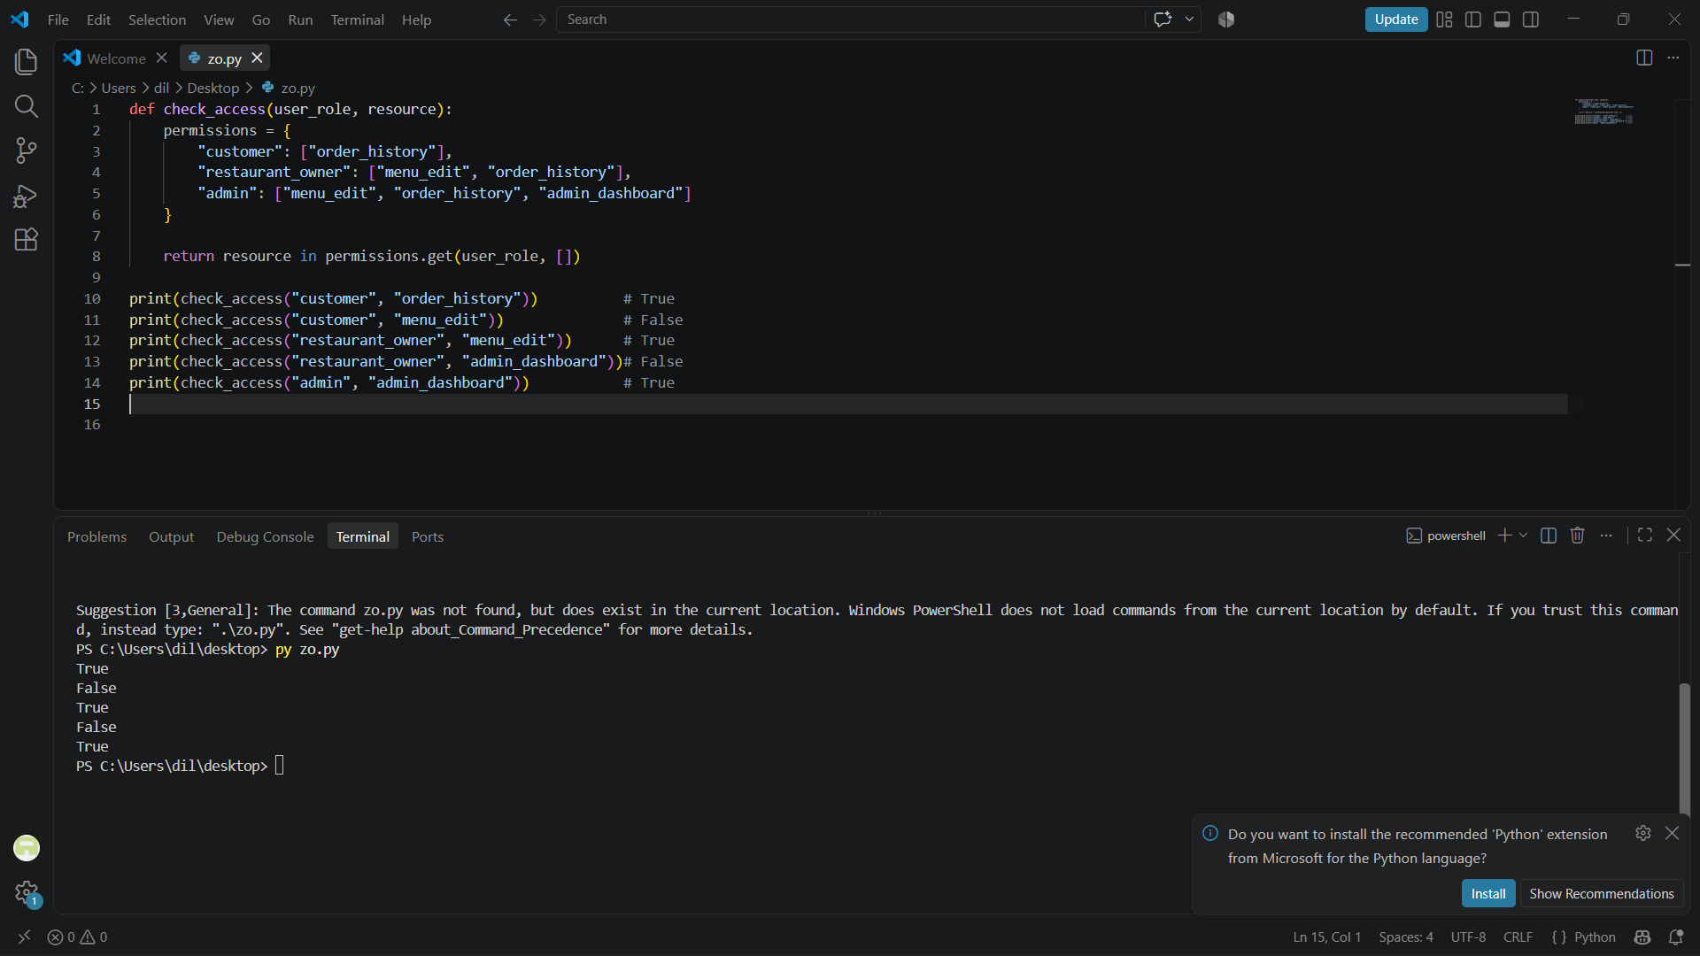
Q3. Two-Factor Authentication (2FA) Using a 6-Digit OTP
This Python program first checks the password. If it is correct, it generates a random 6-digit OTP, displays it in the console for this simulation, and asks the user to enter it.
import random
correct_password = "paytm123"
password = input("Enter password: ")
if password == correct_password:
otp = random.randint(100000, 999999)
print("Your OTP is:", otp) # Simulation only
entered_otp = int(input("Enter OTP: "))
if entered_otp == otp:
print("Login Successful")
else:
print("Invalid OTP")
else:
print("Incorrect Password")
Note: Real applications do not normally display the OTP in the same login console; they deliver it through a separate trusted channel. Here it is displayed only because the question asks for a simulation.
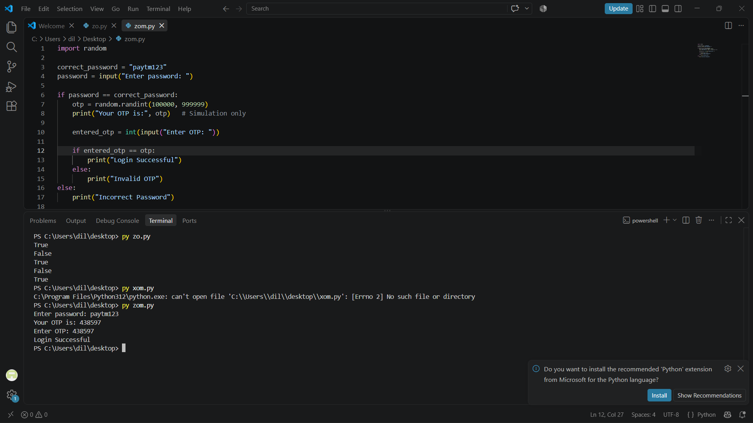
Q4. Filter Premium Users Who Logged In Within the Last 7 Days
Given today = 2024-06-10, this JavaScript function keeps only users who are premium and whose last login is within the previous 7 days.
<!DOCTYPE html>
<html>
<head>
<title>Premium Users</title>
</head>
<body>

<h2>Premium Users Logged In Within Last 7 Days</h2>

<div id="output"></div>

<script>
const users = [
{ username: "Aman", isPremium: true, lastLogin: "2024-06-09" },
{ username: "Simran", isPremium: false, lastLogin: "2024-06-08" },
{ username: "Ravi", isPremium: true, lastLogin: "2024-05-25" },
{ username: "Neha", isPremium: true, lastLogin: "2024-06-04" }
];

function recentPremiumUsers(users) {
const today = new Date("2024-06-10");
const sevenDaysAgo = new Date(today);
sevenDaysAgo.setDate(today.getDate() - 7);

return users.filter(user => {
const loginDate = new Date(user.lastLogin);

return user.isPremium &&
loginDate >= sevenDaysAgo &&
loginDate <= today;
});
}

const result = recentPremiumUsers(users);

result.forEach(user => {
document.getElementById("output").innerHTML +=
user.username + " - " + user.lastLogin + "<br>";
});
</script>

</body>
</html>
Expected matching users in this sample: Aman (2024-06-09) and Neha (2024-06-04). Both are premium and logged in within the 7-day window.
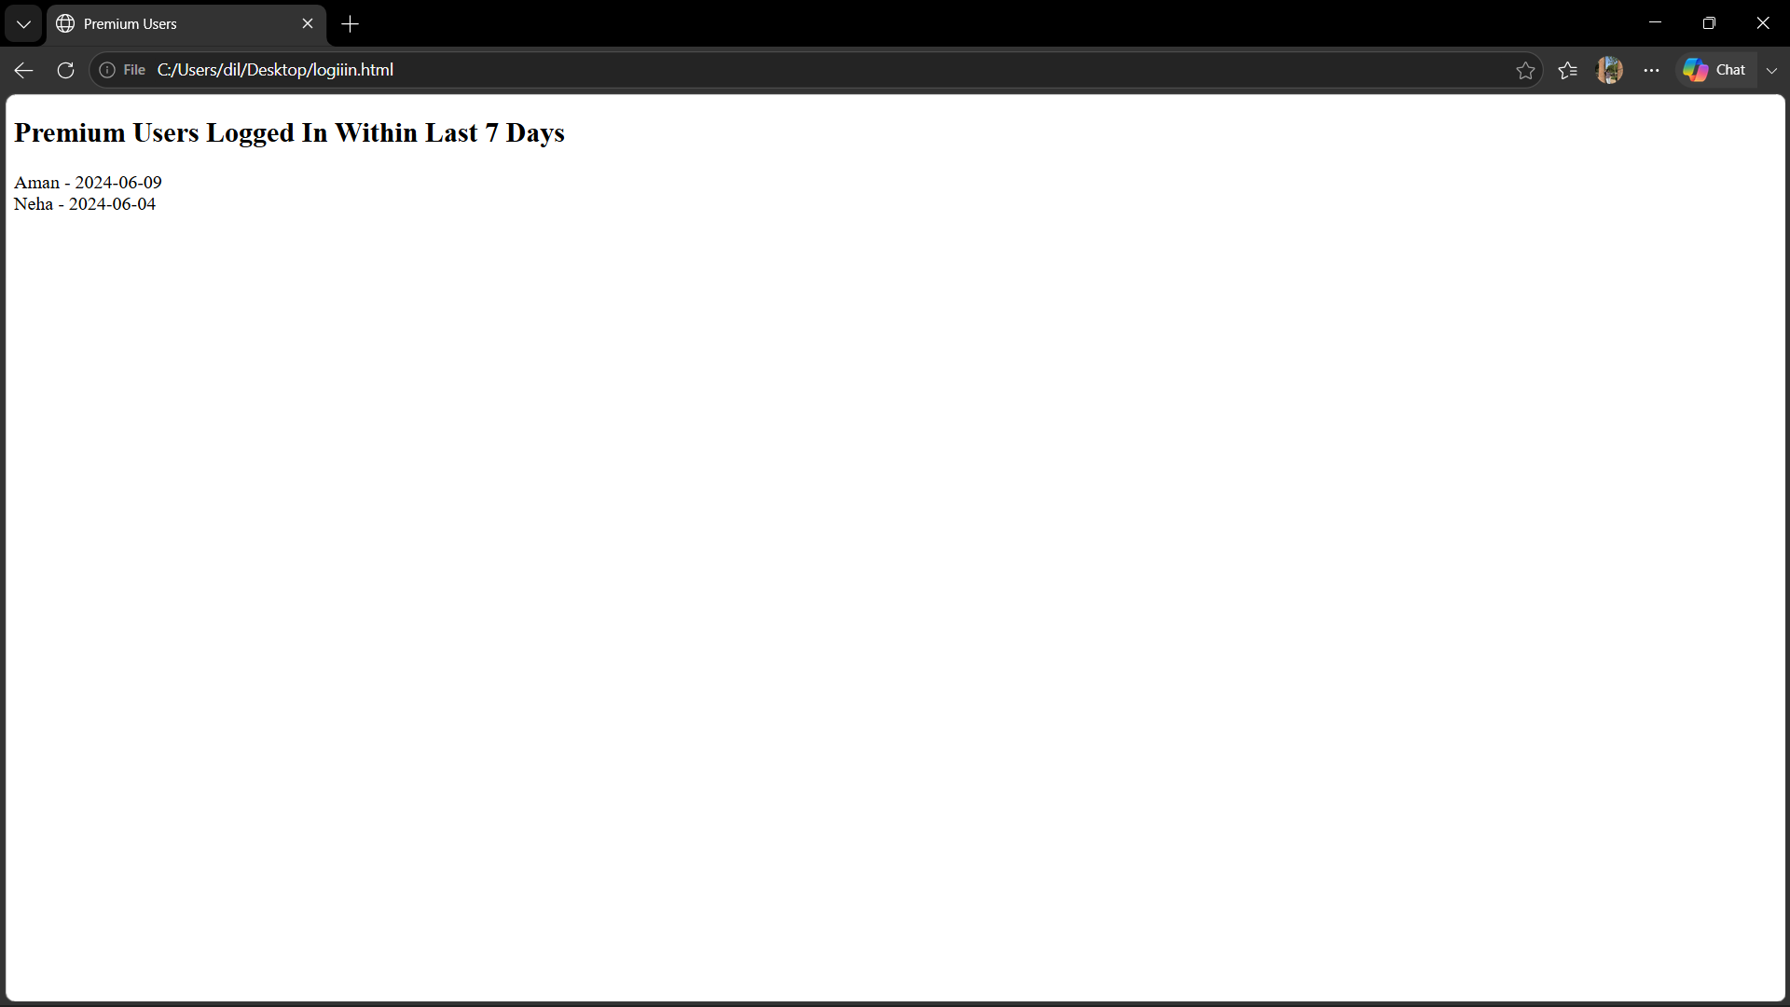
Q5. Five Common Access-Control Mistakes and Their Fixes
Mistake | Simple Meaning | One-Line Fix
Checking permission only in the user interface | A hidden button may stop normal users, but an attacker can still call the server/API directly. | Check authorization on the server for every protected request.
Giving users more permissions than needed | A normal account may receive admin-like access unnecessarily. | Follow least privilege and grant only the permissions required for the role.
Insecure direct object access | Changing an ID in a request may expose another user's order, profile, or file. | Verify that the logged-in user is authorized to access the requested object.
Weak or missing session protection | Stolen or long-lived sessions can let another person act as the user. | Use secure session tokens, expiration, HTTPS, and re-authentication for sensitive actions.
Forgetting to protect new API endpoints | A newly added route may accidentally be left without an authorization check. | Use centralized authorization middleware and test every protected endpoint.
Conclusion
This assignment demonstrates basic authentication, role-based access control, two-factor authentication, filtering users by conditions, and common access-control mistakes. These concepts help applications ensure that users can access only the data and functions they are authorized to use.

